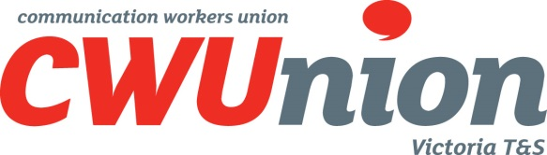 | T&S Branch  DAN DWYER Secretary  M. PO Box 415, Carlton South Vic 3053  A. B2/L3, Trades Hall, 2 Lygon St. Carlton South  P. 03 9663 6815  ABN 13 511 341 559

Ref: SLD 25/15

CWU T&S WEEKLY BULLETIN NO 2025/11 – 23 MARCH 2025
CWU T&S Branch cwu.asn.au
You're never alone when you're a union member
Click here to join CWU TS Branch

TZV APPEAL MENTORING ALLOWANCE
The appeal by TZV was heard in the Federal Court on Friday. The decision has been reserved.
TZV SUPPORT EBA
Our Steering Committee is currently reviewing the large number of claims suggested for our Log of Claims. We will publish the Draft Log soon, seeking any further claims and feedback. More
OPTUS EBA VOTE
The ballot for the Optus Employment Partnership Agreement (2025) was open from 10am Wednesday 12 March 2025 and concluded at 5pm on Monday 17 March 2025. 96% of those who voted, voted ‘Yes’ to approving the agreement. More
OPTUS SHIFT HANDOVER
The dispute over the shift handover payments will return to Court this week for further Conciliation.
TELSTRA OPTICAL FIBRE CASE
We have emailed all those who registered with us. We continue developing a list of members to join our claim for upgrading from CFW4 to CFW5. To register, simply email office@cwu.asn.au with a note.
TELSTRA JOB DESCRIPTIONS
We (the whole union) met again with Telstra to discuss the CFW4 Job Description and exchange views. A number of amendments have been proposed and discussed. We are very clear – the new JDs are not to water down the interpretation of the Case our Branch just won in the Court.

TELSTRA VIVA – SHOULD WE WORRY?
Monitoring “spyware” such as Viva has the ability to closely monitor your work, your speed, your times and your other activities. The intrusion is limited, not by the ability of the software, but by promises. A forum is needed by our IT savvy members to assist us. What do you think? More
NBN SOD EOD CASE
Discussions about our Statement of Claim and case details continue. The matter is listed for a directions hearing this week.
NBN EBA
The NBN ABA was approved by the FWC this week. A copy with a linked index is on our web site. The FWC however did not approve the EBA until NBN gave undertakings as set out below. These are also on our web site. See the NBN EBA with undertakings.
NBN EBA UNDERTAKINGS
These undertakings are provided on the basis of issues raised by the Fair Work Commission in the application before the Fair Work Commission. See the NBN EBA with undertakings. Clause 13.2: New clause 13.3. More
NOKIA VOTE ON MONTHLY PAY
We have initiated proceedings in the Court alleging that Nokia breached the EBA and Award by unilaterally moving to monthly pay. The matter is back before the Court on Friday. The vote closed on Friday, but we have not been told the result More
To unsubscribe simply email office@cwu.asn.au with the word unsubscribe with your name

Yours faithfully,

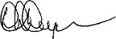

DAN DWYER
Secretary
Communication Workers Union
Telecommunications and Services Branch
m. 0428 942 878
e. ddwyer@cwu.asn.au

